Cornwall ATF Visit to Lanhydrock: July 2025
By Tim Kellett
The Darley Oak is Cornwall’s most significant and oldest tree. It has stood on the edge of Bodmin Moor for approximately 1000 years. The River Fowey flows from the moor down to the south coast through Lostwithiel to the harbour of Fowey. This river valley has the most interesting treescape in the county. It is rich in ancient and veteran trees with many special sites such as Boconnoc, Ethy, Restormel and the National Trust site of Lanhydrock where this ATF public event was held in July.
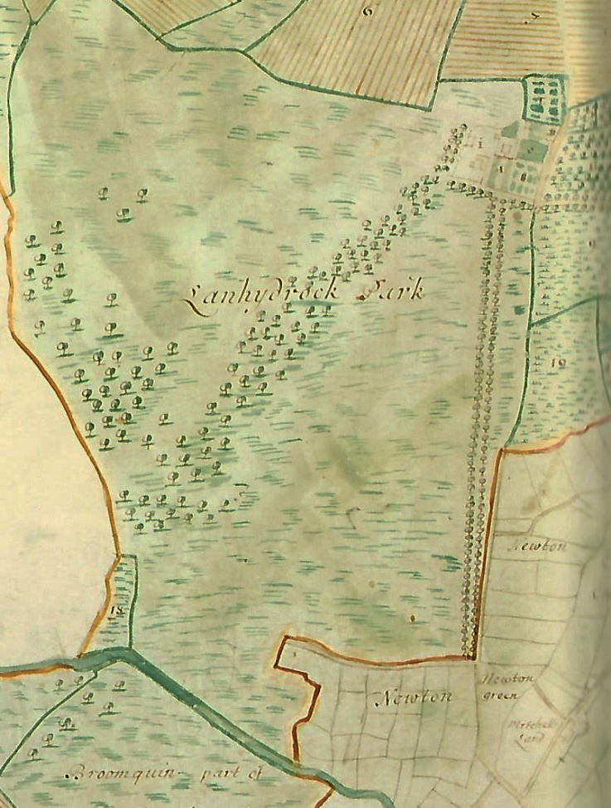
Extract from the Joel Gascoigne hand painted map of 1699 in the Lanhydrock Atlas.
We were fortunate to have access to The Lanhydrock Atlas, which is a collection of detailed maps of all land owned by the Robartes family including their home at Lanhydrock. The maps show a main avenue with parkland on one side and an ancient woodland (now called the Great Wood). This early avenue was created with Sycamore trees, popular with landscapers in the 17th century. In the 19th century the avenue was completely replaced with a double row of beech trees. Many of these trees are reaching the end of their life which is causing concern for the Lanhydrock team. Their countryside manager Steve Kirkpatrick accompanied us on the walk and explained how they were one of the first National Trust sites to adopt a policy to plant mixed species (with beech dominant) in a previously single species avenue.
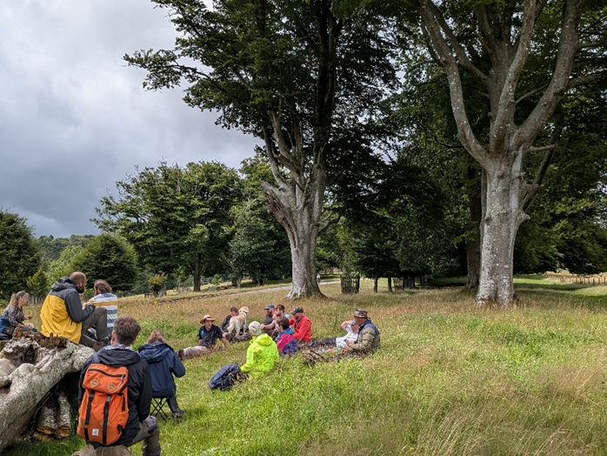
Lunchbreak beside the double row of beech on the avenue. Younger replacements can be seen behind.
Image credit: Tim Kellett.
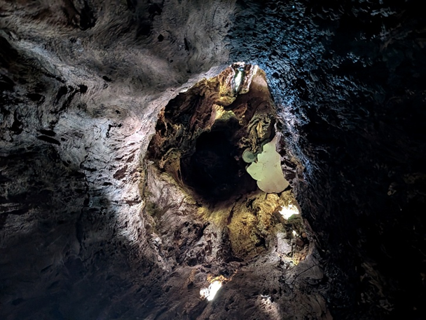
Inside a hollow beech looking vertically up the trunk. On the right of centre you can see the white underside of Ganoderma Australe (also known as Adspersum). This fungus colonises and decays the dead ripewood of the beech, producing a white rot. Most of the older beeches have a lot of decay features and some will be hollow in the trunk but may not be as visible as this specimen.
Image credit: Tim Kellett.
A grove of trees close to the house contains a few veteran sycamore with hollows (not the original trees of the avenue), an oak tree with Lobaria pulmanoria lichen, and a magnificent but small ancient pollarded common lime which has fragmented revealing a completely hollow interior. The hollow lime is an attractive photo opportunity for some of the 500,000 visitors the site receives each year. This area has been fenced off to protect the roots from severe compaction. Interestingly the rangers have cut some of the lower branches of several trees in this zone to replicate the browse line in the rest of the park.
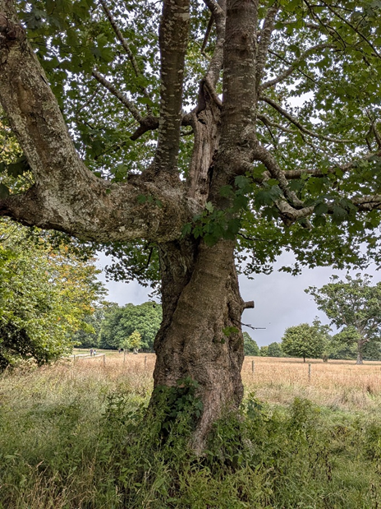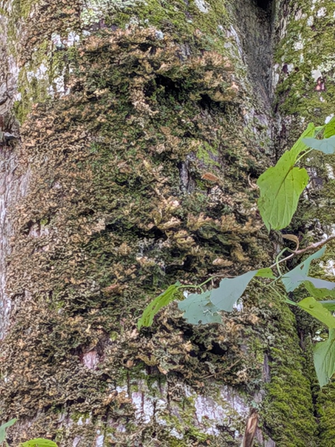Left: A veteran hollowing sycamore in the fenced grove.
Right: A dried-out colony of Lobaria pulmanoria on the side of this oak within the fenced grove.
Image credits: Tim Kellett.
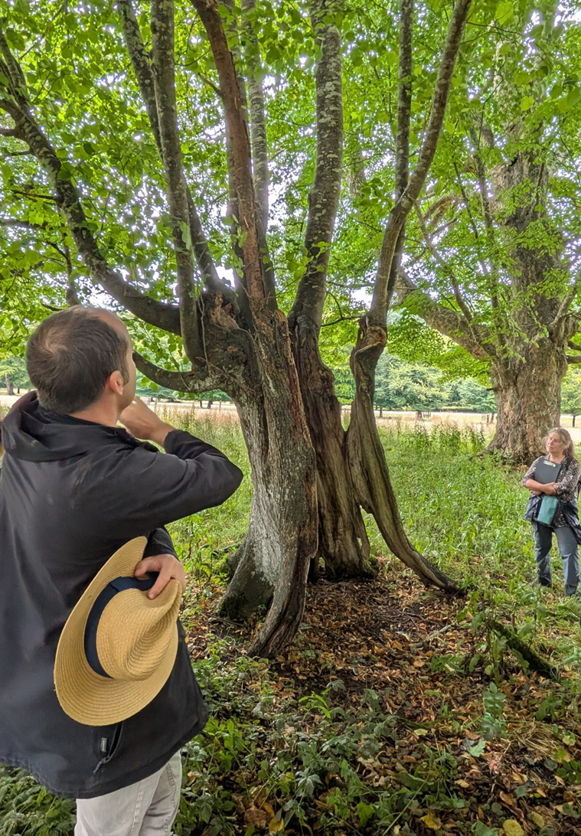
Steve Kirkpatrick, National Trust’s Countryside Manager, explains how they are managing the site of this ancient hollow lime pollard.
Image credit: Tim Kellett.
We debated long and hard about thinning of the lime canopy to avoid structural collapse of the thin wall of the tree and its functional units. The suggestion from one VETcert arb to selectively poll-thin (cut out occasional poles where duplicated) was considered the most sensible. Further thinning (haloing) of some surrounding trees would also be considered in the longer term so not to expose the lime to too much wind stress and sunlight at one time.

We spent some time examining the triple oak, a tree that has three separate stems but fused at the base and fused in the canopy. Or was it one multistem tree that has fragmented or was coppiced early in its life? The majority preferred the first explanation, probably a bundle planting. We could come back when the tree comes into first leaf to see if all three components leaf on the same day. We could also do with a DNA test to see if the three stems are the same or closely related. This was a fantastic tree with many veteran features. One stem was hollow with a huge high level burr colonised by what we thought were fruiting bodies of Fomitiporia robusta.

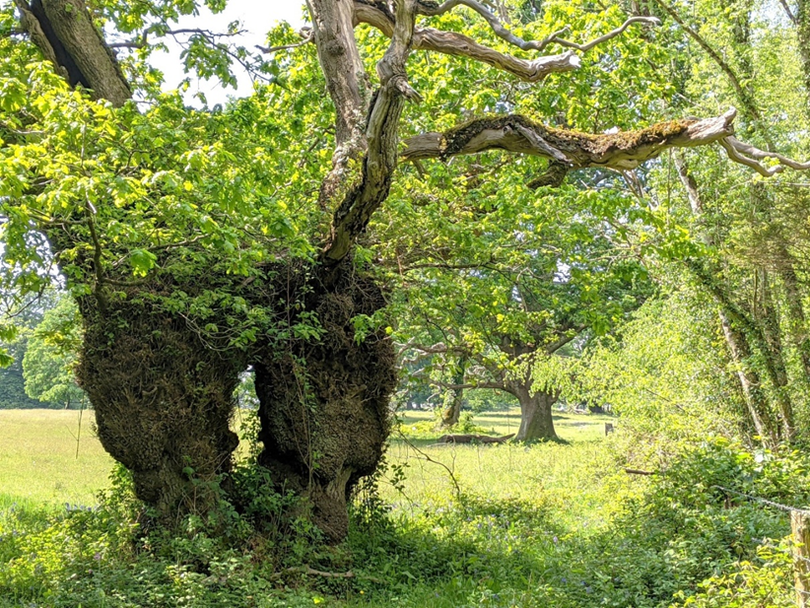
The pedunculate triple oak, with three stems, hollowing trunks, and large deadwood branches. The individual stems are between two and three metres in girth and it has been recorded as a veteran multistem on the Ancient Tree Inventory.
Image credit: Tim Kellett.
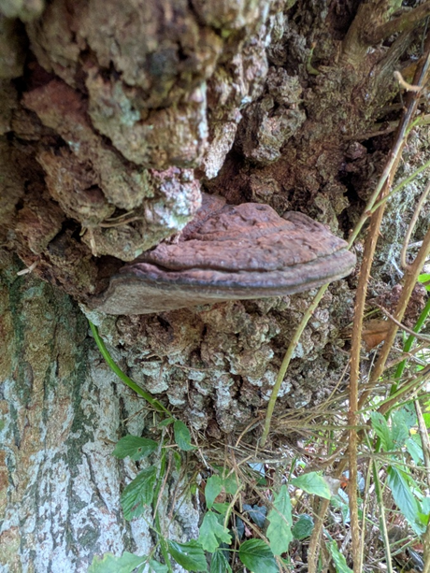
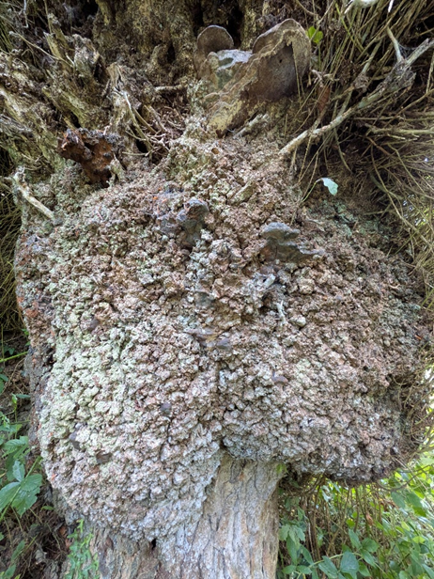
Huge burrs on the triple oak, colonised with an unidentified fungi (darker shapes in the burr to the left) and Ganaoderma australe (aka adspersum) at the base of the burr.
Image credit: Tim Kellett.
The oldest tree we visited on the estate was a 5.4m girth pedunculate oak. This was a pollard though not managed for a very long time. It was also hollow with a large opening on one side. The tree was covered in the dry bark lichen community visible as white patches on the lower trunk. The hollow interior was characterised by the cuboid brown rot, typical result of the colonisation of the beefsteak fungus, though fruiting bodies were not visible on this day.
When we looked at the full version of the 1699 map, we realised that this oak was not in the original parkland. It was on the right-hand edge of the map shown above, to the right of the field marked 12. Beyond those fields were open pasture or downs. So, this tree probably was retained as one of the original boundary trees between the fields and the downs. Someone needs to do more research!
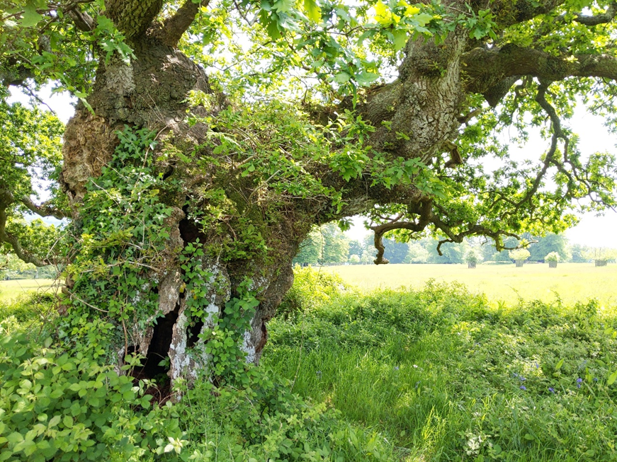
Ancient pollard showing white dry bark community of lichens and large holes into hollow trunk.
Image credit: Tim Kellett.
This old oak, however, is dominated by a younger oak just alongside. It is younger but possibly 250-300 years old compared to the 400-450 of the hollow oak. The view below shows how the younger tree overshades the older resulting in an imbalanced crown. This presented an interesting challenge for the management team as the younger oak was still a valuable veteran. They have carried out a first phase crown cutting on one side of the younger tree. Look closely and you can see how more daylight is exposed to the older tree’s crown on the shaded side.

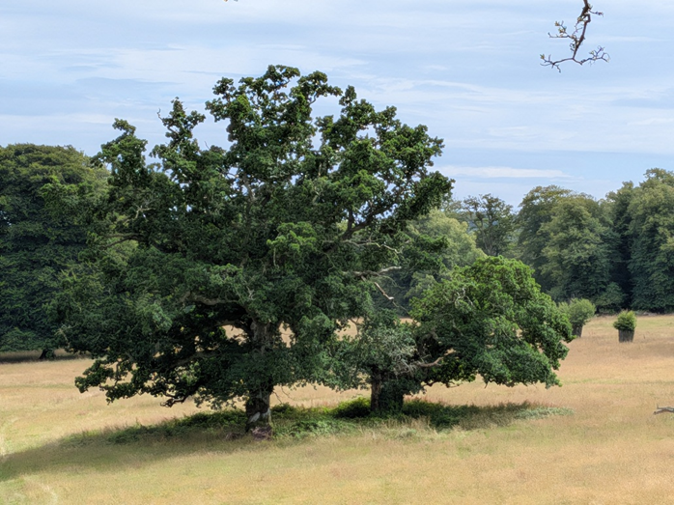
The ancient pollard oak (on the right) is overshaded by a veteran oak standing alongside. Some initial cutting of the younger oak has been undertaken by the National Trust team to allow more light to the older canopy.
Image credit: Tim Kellett.

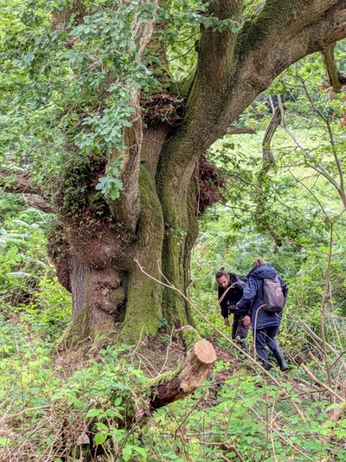
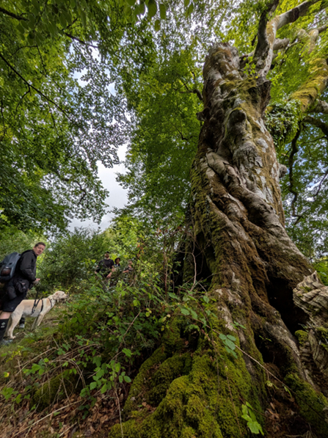
Left: A twisting ancient beech 5.42m girth in a small woodland on the edge of the parkland.
Right: Functional units developing on this 4.43m girth veteran pedunculate oak in the same woodland.
Image credits: Tim Kellett.
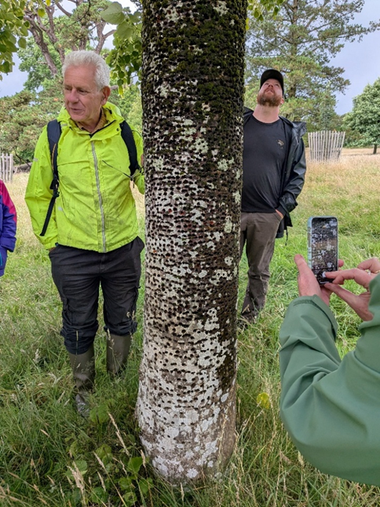
A young lime tree peppered by rows of small holes, some of them freshly cut – or pecked. Steve Kirkpatrick from the National Trust related how he once witnessed a green woodpecker pecking new holes through the bark.
Image credit: Tim Kellett.
This event was facilitated by Tim Kellett and James Gregory from Cornwall ATF and Steve Kirkpatrick, Countryside Manager at Lanhydrock, National Trust.

